**Manv rachna university**

**Combined lab files python programing**

**Submitted by : Aakif**

**2k19csuno1121**

**Lab1**

1/14/2021





Enter number 2: 7

Number 1: 6

Number 2: 7



**Lab 2**

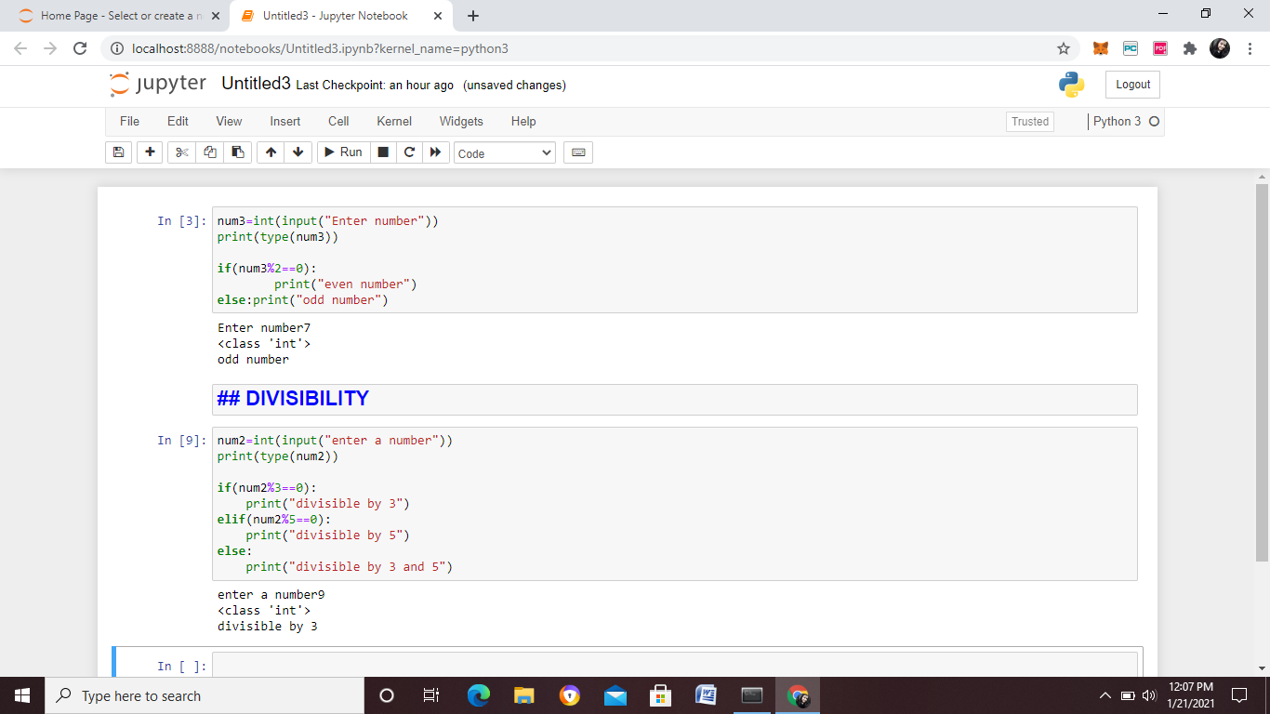

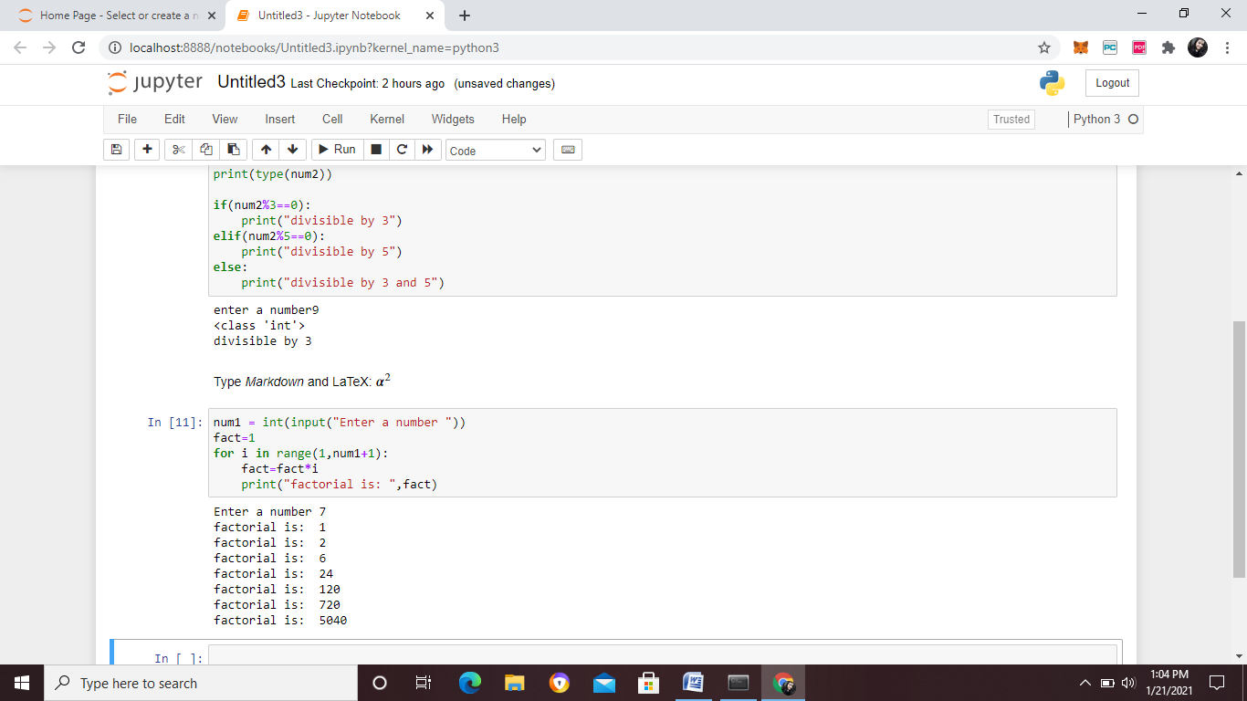

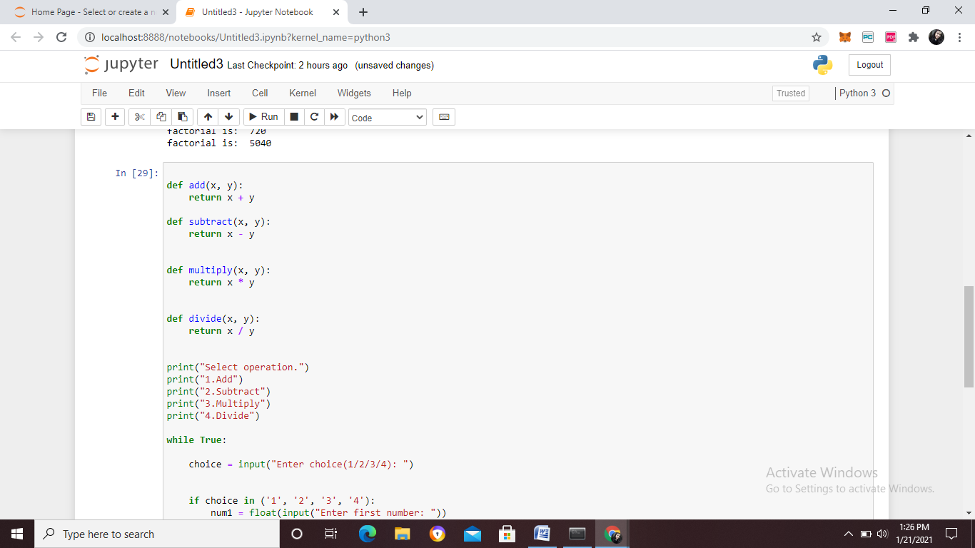

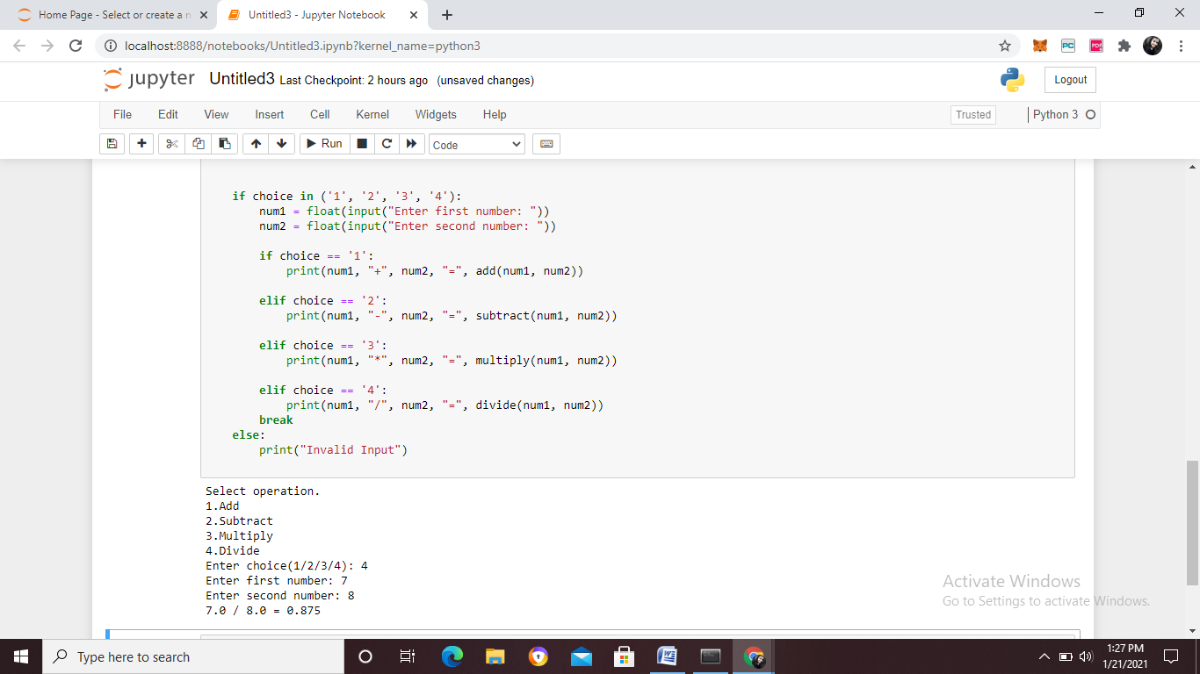

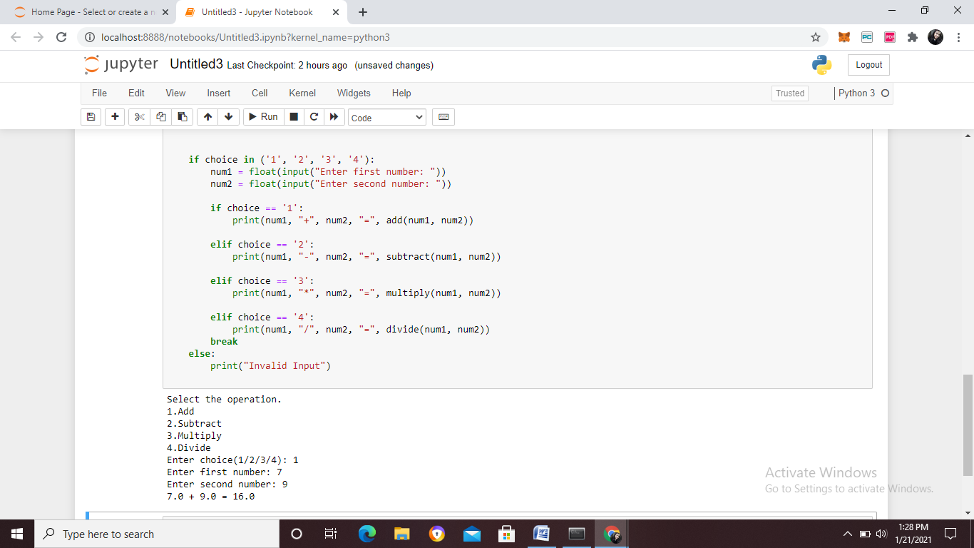

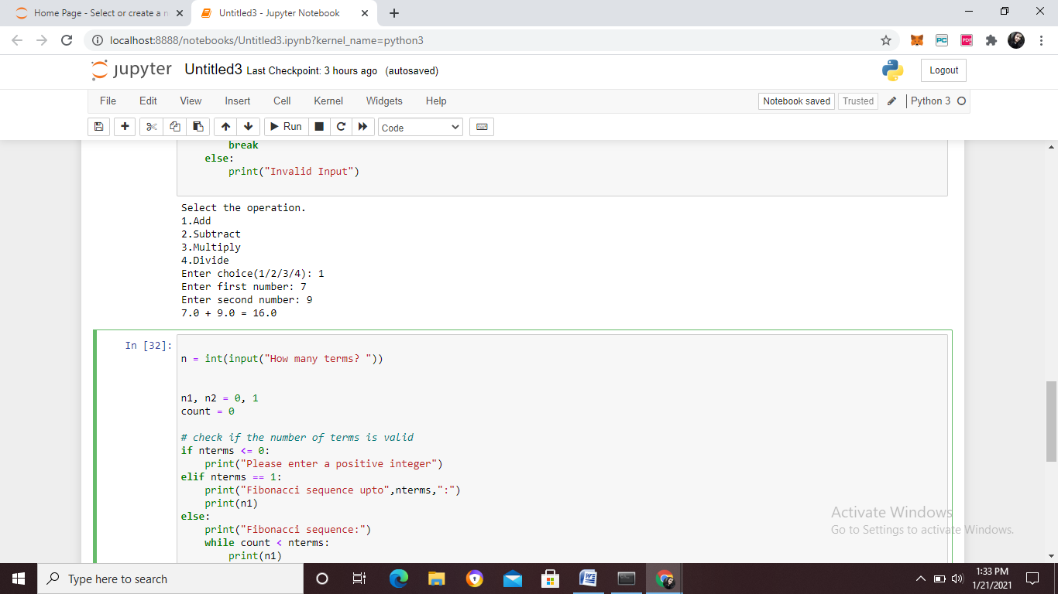

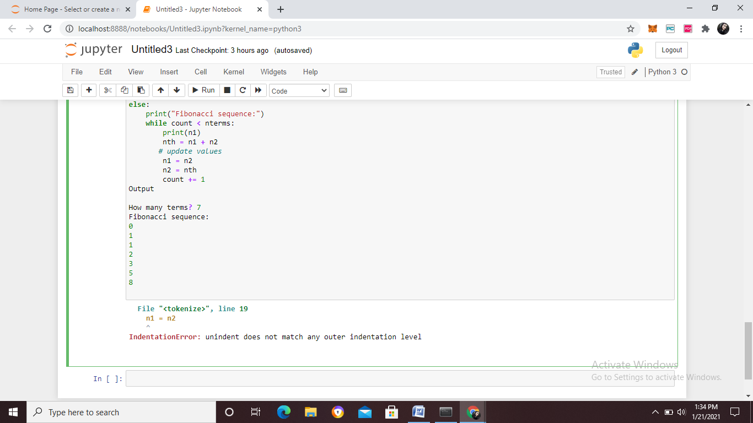

def pypartt(n):

for i in range(0, n+1):

for j in range(0, i+1):

print(" * ",end ="")

print("\r")

n = 5

pypartt(n)

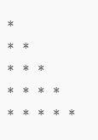

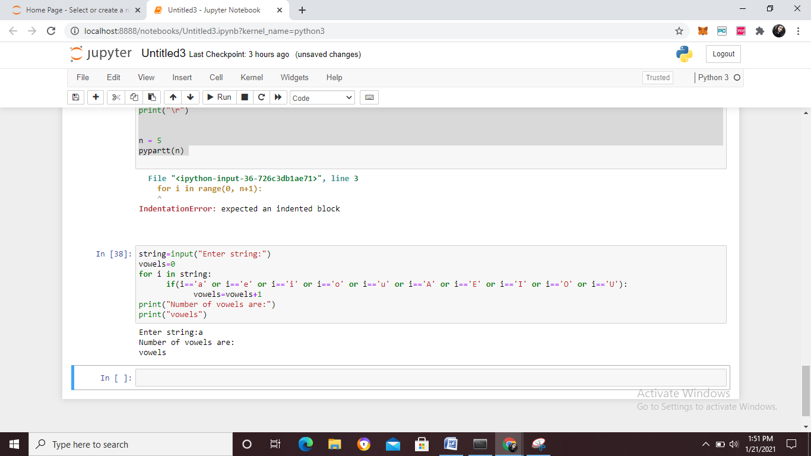

**Lab 3**















def pypartt(n):

for i in range(0, n+1):

for j in range(0, i+1):

print(" * ",end ="")

print("\r")

n = 5

pypartt(n)





**Lab 4 and 5**



**MANAV RACHNA UNIVERSITY, FARIDABAD**

**Department of Computer Science and Technology**

**Course: B.Tech(CST) Semester:IV Subject: Programming for Problem Solving using Python(CSW208B) Session: 2020-21**

***Lab 4-5:*** *Operation on Tuples and List: hands-on practice*

***Learning Outcome*:** *Student will be able to implement Tuple and List:*

***Blooms Taxonomy Level****: BT1, BT2, BT3*

***SUBMITTED BY*** *-AAKIF*

***ROLL NUMBER****-1121*

**1.** Write a Python program to create a tuple.  t1= ()

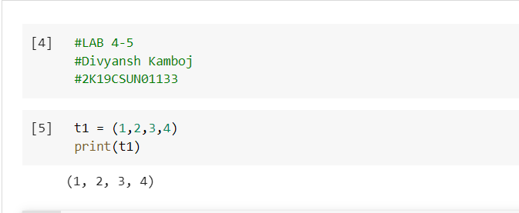

**2.** Write a Python program to create a tuple with different data types.

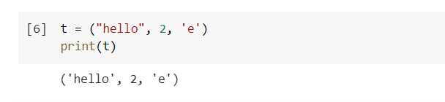

**3.** Write a Python program to create a tuple with numbers and print one item.

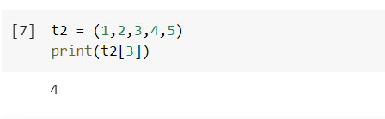

**4.** Write a Python program to unpack a tuple in several variables.

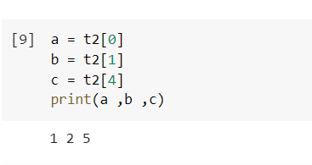

**5.** Write a Python program to add an item in a tuple.

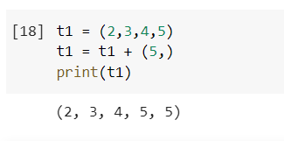

**6.** Write a Python program to convert a tuple to a string.

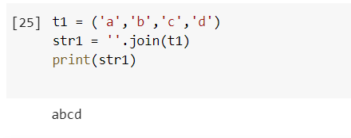

**7.** Write a Python program to get the 4th element and 4th element from last of a tuple

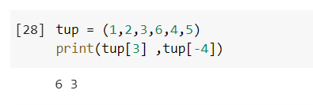

**8.** Write a Python program to create the colon of a tuple.

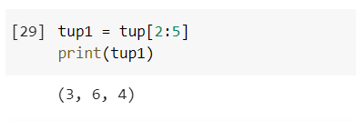

**9.** Write a Python program to find the repeated items of a tuple.

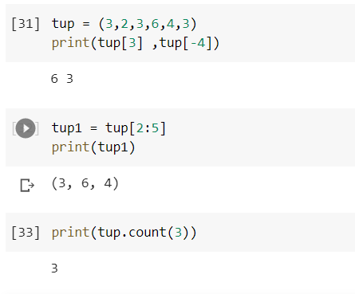

**10.** Write a Python program to check whether an element exists within a tuple.

**11.** Write a Python program to convert a list to a tuple.

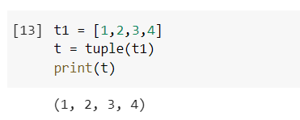

**12.** Write a Python program to remove an item from a tuple.

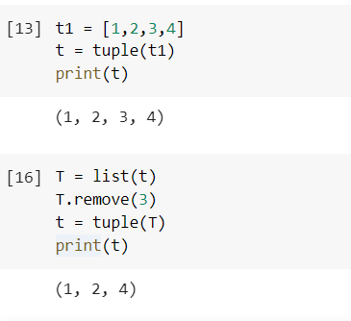

**13.** Write a Python program to slice a tuple

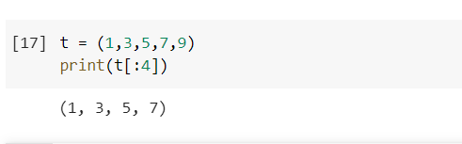

**14.** Write a Python program to find the index of an item of a tuple.

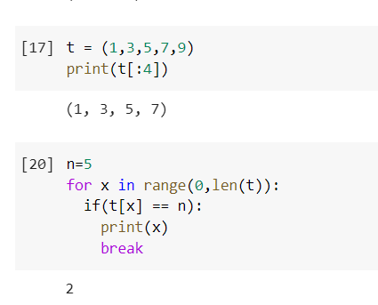

**15.** Write a Python program to find the length of a tuple.

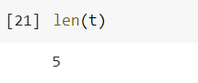

16. Write a Python program to reverse a tuple.

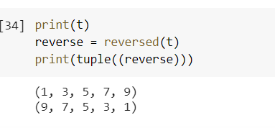

List

**1.** Write a Python program to sum all the items in a list.

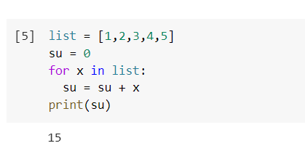

**2.** Write a Python program to multiplies all the items in a list. 

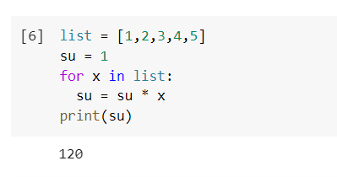

**3.** Write a Python program to get the largest number from a list

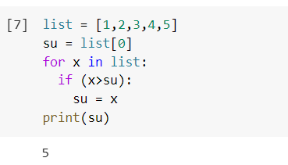

**4.** Write a Python program to get the smallest number from a list.

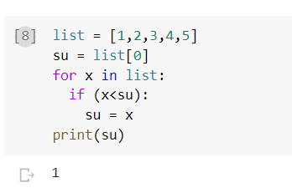

**5.** Write a Python program to count the number of strings where the string length is 2 or more and the first and last character are same from a given list of strings   
Sample List : ['abc', 'xyz', 'aba', '1221']  
Expected Result : 2

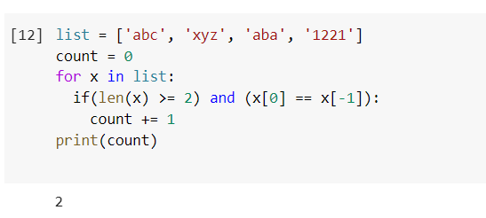

**6.** Write a Python program to get a list, sorted in increasing order by the last element in each tuple from a given list of non-empty tuples.    
Sample List : [(2, 5), (1, 2), (4, 4), (2, 3), (2, 1)]

Expected Result : [(2, 1), (1, 2), (2, 3), (4, 4), (2, 5)]

**7.**Write a Python program to remove duplicates from a list.

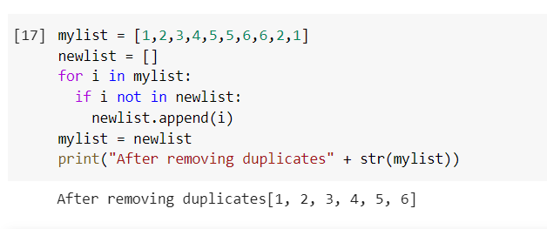

**8.**Write a Python program to check a list is empty or not.

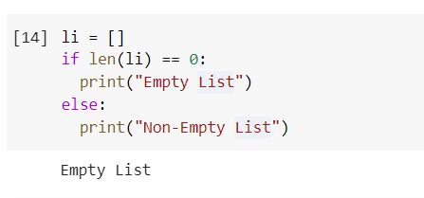

**9.**Write a Python program to clone or copy a list.

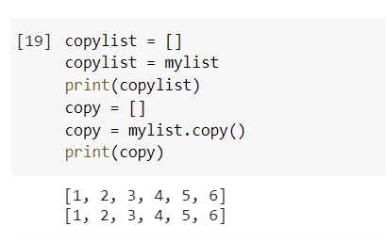

**10.**Write a Python program to find the list of words that are longer than n from a given list of words.

**11.**Write a Python function that takes two lists and returns True if they have at least one common member.

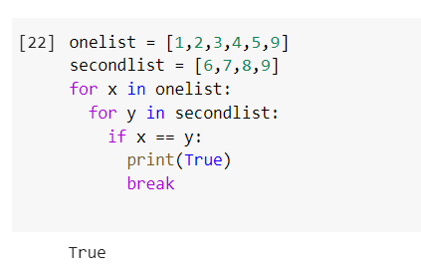

**12.**Write a Python program to print a specified list after removing the 0th, 4th and 5th elements.    
Sample List : ['Red', 'Green', 'White', 'Black', 'Pink', 'Yellow']  
Expected Output : ['Green', 'White', 'Black']  
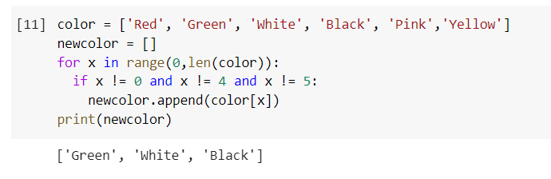

Lab 6

**LAB -6**

**1)Create an empty dictionary.**

In [1]: dict**=**{}

Out[1]: {}

1. **Create the following dictionary**

Key value

1. 10
2. 20



Out[2]: {'A': 10, 'B': 20}

1. **Create a dictionary with different datatypes for keys.**



Out[1]: {'A': 'D', 2: 'R', 3.8: '11'}

1. **Print all the items of a dictionary**



{'A': 'D', 2: 'R', 3.8: '11'}

**5.Delete an element of a dictionary**



Out[3]: {'A': 'D', 3.8: '11'}

**6.Delete full dictionary**



**7. Print a value for a key**



11

**8.To check if a key id present in a dictionary**



Out[7]: True

**9.Update a value of a key**



{'A': 'D', 2: 'R', 3.8: '2k19'}

1. **Add a new key value pair**



Out[10]: {'A': 'D', 2: 'R', 3.8: '11', 'b': '2K19'}

1. **Print dictionary for keys{1,10} and values as square of keys**

In [33]: dict1**=**{}

{1: 1, 2: 4, 3: 9, 4: 16, 5: 25, 6: 36, 7: 49, 8: 64, 9: 81, 10: 100}

1. **Print nested dictionary**



{1: 'a', 2: 'b', 3: {4: 'c', 5: 'd'}, 6: 'e'}

1. **Concatenate three dictionaries**

Sample Dictionary : dic1={1:10, 2:20} dic2={3:30, 4:40} dic3={5:50,6:60} Expected Result : {1: 10, 2: 20, 3: 30, 4: 40, 5: 50, 6: 60}

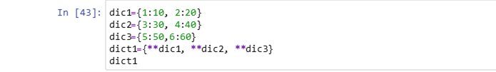

Out[43]: {1: 10, 2: 20, 3: 30, 4: 40, 5: 50, 6: 60}

1. **Sum all the values of a dictionary.**

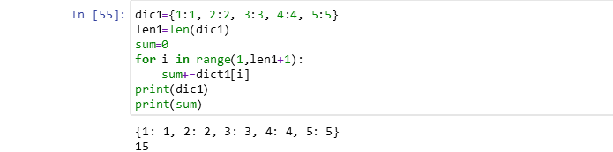

1. **Accessing an element of a nested dictionary**



Out[60]: 'd'

1. **Write a Python script to print a dictionary where the keys are numbers between 1 and 15 (both included) and the values are square of keys.**

Sample Dictionary {1: 1, 2: 4, 3: 9, 4: 16, 5: 25, 6: 36, 7: 49, 8: 64, 9: 81, 10: 100, 11: 121, 12: 144, 13: 169, 14: 196, 15: 225}

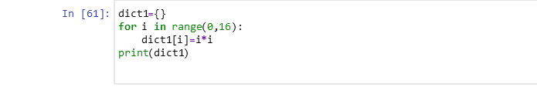

{0: 0, 1: 1, 2: 4, 3: 9, 4: 16, 5: 25, 6: 36, 7: 49, 8: 64, 9: 81, 10: 100, 11: 121, 12: 144, 13: 169, 14: 196, 15: 225}

1. **Insert factorial of keys in values. And print dictionary**

d={1:1,2:2,3:6,4:24,5:120….}

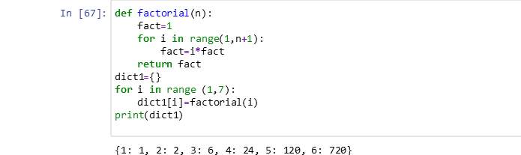

**Sets**

1. **Write a program to create a set**



Out[3]: {1, 2, 3}

1. **Write a program to add an element to set**



{1, 2, 3, 4, 5}

1. **Write a program to add multiple items using update function**

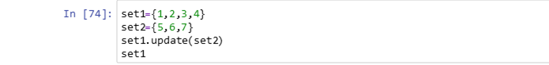

Out[74]: {1, 2, 3, 4, 5, 6, 7}

1. **Write a program to find length of a set**



4

1. **Write a program to remove value from a set**



Out[77]: {1, 2, 4}

1. **Write a program to pop an element from a set**



Out[81]: 1

1. **Write a program to update a set**

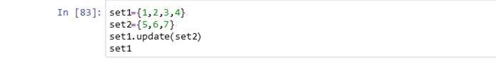

Out[83]: {1, 2, 3, 4, 5, 6, 7}

1. **Write a Python program to create an intersection of sets.**



{3, 4, 5}

1. **Write a Python program to create a union of sets.**

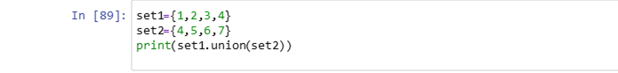

{1, 2, 3, 4, 5, 6, 7}

1. **Write a Python program to clear a set.**



Out[90]: set()

1. **Write a Python program to issubset and issuperset.**

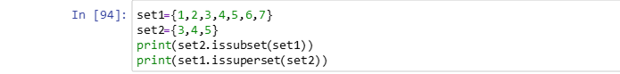

True

True

1. **Write a Python program to create set difference.**

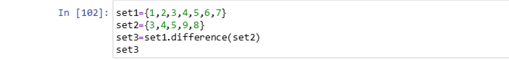

Out[102]: {1, 2, 6, 7}

1. **Write a Python program to create a symmetric difference.**

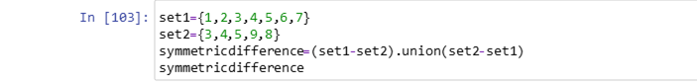

Out[103]: {1, 2, 6, 7, 8, 9}

In [ ]: 